Boards Bugs Priority changes Documents

1.Organization settings -- > Process select Severity, if we want add additional tab click on New feed.

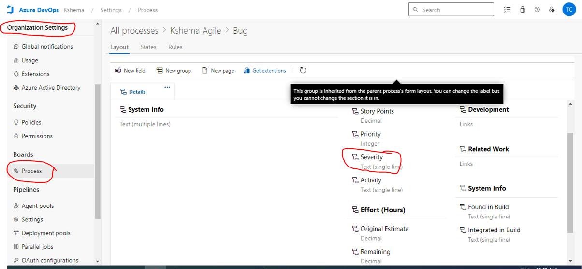

2. Click on severity and click on … dots edit here as below showing

3. Enter below values as per our requirements.

**How to add Bug statsus:-**

**Go to organization settings:-process->select BUG🡪create new state.**

